**Cloud** **Computing**

**Introduction**: Cloud computing is the delivery of computing services such as servers, storage, databases, networking, software, and analytics over the internet instead of relying on local hardware to offer faster innovation, flexible resources, and economies of scale. It is a model for enabling convenient, on-demand network access to a shared pool of configurable computing resources (e.g. networks, servers, storage, applications and services)

that can be rapidly provisioned and released with minimal management effort or service provider

interaction.

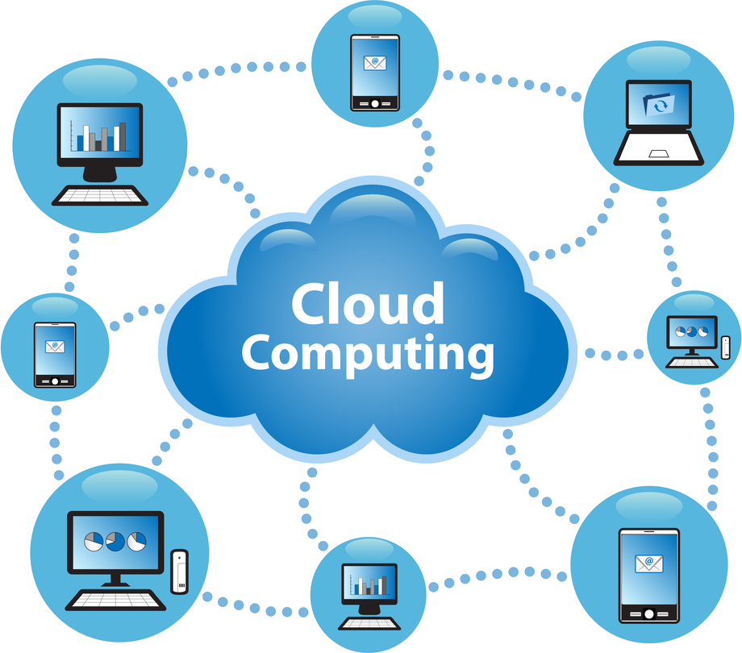

[This Photo](https://freepngimg.com/png/23920-cloud-computing-photos) by Unknown Author is licensed under [CC BY-NC](https://creativecommons.org/licenses/by-nc/3.0/)

**Types of Cloud Computing:**

* **Public Cloud:** A third-party provider owns and operates the cloud, which provides computing resources like storage and servers over the internet. In this model, the cloud provider manages the infrastructure, and the resources are shared among multiple customers (also known as "multi-tenant"). Users can access and use the resources on a pay-per-use basis, and they are shared among many users.

**Examples**:

* **Amazon Web Services (AWS)=** **The most popular public cloud provider, Amazon Web Services (AWS), provides a variety of cloud services, including computing, storage, and database services.**
* **Microsoft Azure=Azure is a Microsoft public cloud service that offers a variety of cloud services, such as virtual machines, storage, and analytics.**

**Benefits:**

* **Scalability:** Public clouds offer near-infinite scalability since you can quickly increase or decrease your usage based on demand.
* **Cost-Effective:** Youpay only for what you use (pay-as-you-go model), which makes it affordable for businesses of all sizes.
* **Minimal Maintenance:** There is not a need for regular maintenance in public clouds which can prove to be cost effective.

**Considerations:**

* **Security and Privacy Issues:** Public cloud providers oversee protecting the underlying infrastructure, but you are ultimately in charge of ensuring the security of your applications and data. By putting in place the necessary security measures and adhering to best practices, you must make sure that your data is protected.
* **Limited Customization:** Public cloud providers provide a variety of services and solutions, but they might not fully satisfy all your company's unique requirements. There might be little room for customization, and you could have to give up some functions.
* **Downtime:** Due to upkeep, upgrades, or unplanned outages, public cloud services may encounter downtime. You must have backup plans in place to lessen the effects of such downtime on your company.
* **Private cloud:** A privatecloud is a cloud environment used exclusively by one organization. The cloud infrastructure may be hosted either on-site (within the company’s data center) or off-site (managed by a third party), but the key difference is that the resources are not shared with other organizations.

**Examples:**

* **VMware vSphere=**VMware vSphere is a virtualization platform that includes a suite of products for deploying and managing virtual environment.
* **Microsoft Azure Stack=**Microsoft Azure Stack is essentially a private cloud version of the Microsoft Azure public cloud, allowing organizations to run Azure services on their own on-premises hardware.

**Benefits:**

* **Enhanced Security:** Since the infrastructure is devoted to a single organization, private clouds offer a better level of data protection and privacy, lowering the danger of unauthorized access or data breaches.
* **Greater Control:** Private clouds have more control over their resources and hardware than public clouds because it is only accessed by selected users.
* **Customization:** Private clouds enable organizations to better customize infrastructure, security procedures, and applications to match unique business requirements.

Considerations:

• Higher costs: Setting up a private cloud requires significant investment in hardware, software, and ongoing maintenance.

• Maintenance responsibilities: Regular Maintenance and Upgrades are necessary for private clouds, but they can be time-consuming and expensive.

* **Hybrid Cloud:** Acombination of public and private clouds, allowing data and applications to be shared between them. The main aim of combining these clouds (Public and Private) is to create a unified, automated, and well-managed computing environment.

**Examples:**

* **AWS Outposts (Hybrid with Public Cloud Integration) =** AWS Outposts is a service that allows users to extend AWS infrastructure to on-premises locations, enabling a hybrid cloud environment.
* **Microsoft Azure Stack (Hybrid Cloud) =** Microsoft Azure Stack is a hybrid cloud solution offered by Microsoft that allows users to run Azure services within their own on-premises data center

**Benefits:**

* **Flexibility:** Hybrid cloud gives organizations better control over their infrastructure by allowing them to use the public cloud for non-critical tasks and the private cloud for sensitive applications.
* **Optimized workload distributions:** The hybrid cloud gives organizations more flexibility and agility by making it simple to move data between public and private cloud environments.
* **Cost efficiency:** Organizations can benefit from the public cloud's cost reductions while still preserving control over their sensitive data and apps by using hybrid clouds.

**Considerations:**

* **Complexity in management:** Managinghybrid cloud environments can be challenging, particularly when combining several cloud environments, networking, and security.
* **Potential security challenges:** Hybrid clouds can provide additional security difficulties, such as managing identities across several environments and securing data as it is being transferred across clouds, even though they improve security for critical data and applications.
* **Community Cloud: Community cloud is a cloud infrastructure that allows systems and services to be accessible by a group of several organizations to share information. It is owned, managed, and operated by one or more organizations in the community, a third party, or a combination of them.**

**Examples:**

* Ourgovernment organization within Nepal may share computing infrastructure in the cloud to manage data and efficient data sharing while maintaining tight security and compliance with governmental regulations.

**Benefits:**

* **Scalability and flexibility:** The community cloud is flexible and scalable because it is compatible with every user. It allows the users to modify the documents as per their needs and requirements.
* **Cost-effectiveness:** Communitycloud is cost effective because the whole cloud is shared between several organizations or a community.
* **Security:** Community clouds are more secure than the public cloud but less secure than the private cloud.

**Considerations:**

* **Limited to specific groups:** Acommunity cloud is not as widely accessible as a public cloud because it’s limited to organizations with common interests.
* **Complexity in Management:** Becausethe cloud is shared among several organizations, managing the different needs and requirements of each member can be complex.

**Cloud Service Models**

* **Infrastructure as a Service (IaaS):** IaaS is also known as **Hardware as a Service (HaaS)**. It is a computing infrastructure managed over the internet. The main advantage of using IaaS is that it helps users to avoid the cost and complexity of purchasing and managing the physical servers.

**Characteristics** **of** **IaaS**:

These are the following characteristics of IaaS:

* Resources are available as a service
* Services are highly scalable
* Dynamic and flexible
* GUI and API-based access
* Automated administrative tasks

**Example:** DigitalOcean, Linode, Amazon Web Services (AWS), Microsoft Azure.

* **Platform as a Service (PaaS):** Platformas a Service (PaaS) provides a runtime environment. It allows programmers to easily create, test, run, and deploy web applications.

**Characteristics of PaaS:**

These are the following characteristics of PaaS:

* Accessible to various users via the same development application.
* Integrates with web services and databases.
* Builds on virtualization technology, so resources can easily be scaled up or down as per the organization's need.
* Support multiple languages and frameworks.

**Example:** AWS Elastic Beanstalk, Windows Azure, Heroku, Force.com, Google App Engine

**Software as a Service (SaaS):** SaaS is also known as "on-demand software". It is software in which the applications are hosted by a cloud service provider. Users can access these applications with the help of internet connection and web browser.

**Characteristics of SaaS:**

These are the following characteristics of SaaS:

* Managed from a central location
* Hosted on a remote server
* Accessible over the internet
* Users are not responsible for hardware and software updates. Updates are applied automatically.
* The services are purchased on a pay-as-per-use basis.

**Example:** BigCommerce, Google Apps, Salesforce, Dropbox, ZenDesk, Cisco WebEx.

**Benefits of Cloud Computing**

* **Cost Efficiency:** Byleveraging cloud services, businesses can reduce or eliminate the need for significant upfront investments in hardware and minimize ongoing maintenance costs. Instead, they pay for the resources they use, leading to optimized spending.
* **Scalability and Flexibility:** Cloudplatforms provide the ability to quickly scale resources up or down in response to fluctuating demand, ensuring optimal performance without the necessity for overprovisioning.
* **Accessibility and Collaboration:** With cloud computing, data and applications are accessible from anywhere with an internet connection, facilitating remote work and enhancing collaboration among teams across different locations.
* **Automatic Updates and Maintenance:** Cloud service providers handle routine software updates and security patches automatically, ensuring users have access to the latest features and protections without manual intervention.

* **Enhanced Security:** Leading cloud providers invest heavily in advanced security measures to protect data and applications, often surpassing the capabilities of individual organizations. Features such as data encryption, identity management, and regular security audits help safeguard sensitive information.
* **Disaster recovery:** Cloud computing can help businesses recover from disasters by providing backup data and disaster recovery services.

**Challenges of Cloud computing and solutions**

* **Data Security and Privacy:** Storing sensitive data in the cloud raises concerns about unauthorized access, data breaches, and compliance with privacy regulations.

**Mitigation:** Implement robust encryption, access controls, and regularly audit security measures to protect data integrity.

* **Compliance and Legal Issues:** Organizations must adhere to industry-specific regulations and navigate legal complexities, such as data residency requirements and cross-border data transfer laws.

**Mitigation:** Engage with legal experts to ensure cloud services comply with relevant regulations and contractual obligations.

* **Cost Management:** While cloud services can be cost-effective, without proper oversight, expenses can escalate due to factors like unused resources or unexpected usage of spikes.

**Mitigation:** Regularly monitor resource utilization, implement budgeting tools, and optimize workloads to manage costs effectively.

* **Vendor Lock-In:** Dependence on a single cloud provider can make it challenging to migrate to alternative platforms, potentially leading to increased costs or limited flexibility.

**Mitigation:** Design applications with portability in mind and consider multi-cloud strategies to avoid over-reliance on one provider.

* **Performance and Downtime:** Cloud service outages or latency issues can disrupt business operations and affect user experience.

**Mitigation:** Choose providers with strong uptime guarantees, implement redundancy strategies, and monitor performance continuously.